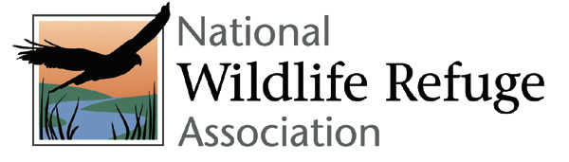

2022 Nomination Categories

The Paul Kroegel - Refuge Manager of the Year Award was established to recognize outstanding accomplishment in the protection and management of our National Wildlife Refuge System. This award is given in honor of Paul Kroegel, the first manager of the first refuge established in 1903 at Pelican Island, Florida, whose dedication and effectiveness set a high standard for those who followed. This award will be presented to a current refuge manager whose accomplishments and attributes are judged to best exemplify Paul Kroegel’s legacy. The award includes a $1,000 check.

The Refuge Employee of the Year Award was established to recognize the outstanding work of the men and women who serve the National Wildlife Refuge System. This award is presented each year to an individual whose career has shown a commitment to the conservation of our natural resources, superior management and/or technical skills, innovation, effectiveness in dealing with outside organizations and the public, and a background that has advanced the cause of wildlife conservation. The award includes a $1,000 check.

The Refuge Volunteer of the Year Award was established to recognize the outstanding accomplishments of volunteers in the operation and management of the Refuge System. The award is presented to volunteers who demonstrate dedication to the goals and objectives of the Refuge System, superior organizations skills, innovation in handling refuge assignments, effectiveness in dealing with the public and dependability. For clarification, Friends board members who are also refuge volunteers are eligible for this award. The award includes a $1,000 check.

The Molly Krival - Refuge Friends Group of the Year Award honors a Friends organization that demonstrates innovation and excellence in advancing the mission of the Refuge System, provides a positive community influence, works as an independent advocate to protect the natural resource, and strives to influence support for the local refuge and the Refuge System as a whole. This award is given in honor of Molly Krival, a pioneer in the Friends movement who mentored new and existing Refuge Friends groups all across the country. The award includes a $2,000 check.

The Refuge Advocate Award is an occasional award that recognizes extraordinary accomplishments in support of the mission of the National Wildlife Refuge System by people or groups other than FWS employees or Friends groups, though individual members of Friends groups may qualify. This award is presented to honor innovation and excellence in advancing the mission of the National Wildlife Refuge System through successfully advocacy for a refuge or the entire Refuge System, resulting in the reduction or elimination of the threat while maintaining a relationship of cooperation and mutual respect with refuge personnel.

The deadline for submission is March 7, 2022.
Electronic nominations are required.
The results will be announced in May 2022
To submit your nomination, please email the completed form to Debbie Harwood at dharwood@refugeassociation.org.

